# Run optimization

We first run preProcessing.sh for pre-processing and then run runScript.py for optimization.

The following is an aerodynamic shape optimization case for the NACA0012 airfoil at low speed:

Case: Airfoil aerodynamic optimization

Geometry: NACA0012

Objective function: Drag coefficient (CD)

Lift coefficient (CL): 0.5

Design variables: 20 free-form deformation (FFD) points moving in the y direction, one angle of attack

Constraints: Symmetry, volume, thickness, and lift constraints (total number: 34)

Mach number: 0.02941 (10 m/s)

Reynolds number: 0.6667 million

Mesh cells: ~4,000

Solver: DASimpleFoam

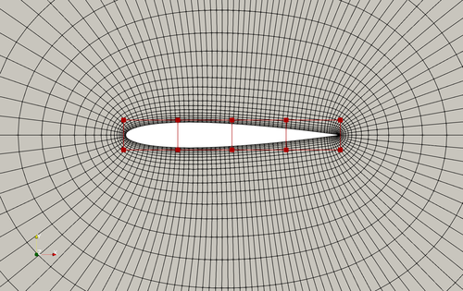

Fig. 1. Mesh and FFD points for the NACA0012 airfoil

To run this case, first download [tutorials](https://github.com/DAFoam/tutorials/archive/main.tar.gz) and untar/extract it. Since we use the pre-compiled DAFoam Docker image, we need to first start the Docker container (a light-weight virtual machine). If you use **Linux**, use the commands on [this page](https://dafoam.github.io/mydoc_get_started_start_docker_linux.html). If you use **MacOS**, use the commands on [this page](https://dafoam.github.io/mydoc_get_started_start_docker_mac.html). If you use **Windows**, use the commands on [this page](https://dafoam.github.io/mydoc_get_started_start_docker_windows.html).

The above command will start a docker container, mount the **current directory** on your local OS (tutorials-main/NACA0012_Airfoil/incompressible) to the container’s **mount** directory, login to the container’s mount directory as dafoamuser, and set the relevant DAFoam environmental variables. You may see something like this on your terminal: dafoamuser@00fb6ceac4da:~/mount$.

**Now you are on the DAFoam Docker container**, run the preProcessing.sh script to generate the mesh:

./preProcessing.sh

Then, use the following command to run the optimization with 4 CPU cores:

mpirun -np 4 python runScript.py 2>&1 | tee logOpt.txt

The optimization progress will be printed to the screen and also written to logOpt.txt (we will elaborate on logOpt.txt later on [this page](https://dafoam.github.io/mydoc_get_started_runscript.html)). This case ran for 18 optimization iterations and took about 15 minutes with Intel 3.0 GHz CPU.

**Note:** For MacOS and Windows, make sure you open the Docker Desktop app before running Docker commands.

**Note:** Treat the Docker container as disposable, i.e., start one container for one optimization run. If the optimization is running and you want to kill it, press ctr+c or ctr+\. After the optimization is done, type exit to exit the docker container and free up the occupied memory.

**Note:** Before re-running a case, run ./Allclean.sh to clean up the previous optimization results.

**Note:** dafoamuser has the sudo privilege and its password is: dafoamuser.

Check [this page](https://dafoam.github.io/mydoc_get_started_post_processing.html) (后处理) for interpreting and post processing the optimization results.